SHULL SCIENCE · JAMES A. GARFIELD LOCAL SCHOOLS
UNIT 2 TEST STUDY GUIDE: ELECTRONS & ATOMIC THEORY
UNIT 2 TEST · S2.2 – S2.5
NAME | DATE | PERIOD

Use a periodic table. Work each section, then check it against your notes. Anything you miss tells you what to practise before the test.

1 · SUBLEVELS, ENERGY LEVELS & FILLING RULES

SUBLEVEL | s | p | d | f
Orbitals
Max electrons
1 The sublevels in n = 3 are ______________ . Level n = 3 holds at most ______ electrons (2n²).
2 Which sublevel fills right after 4s? ________ Which fills right after 5p? ________
3 Name the rule each statement describes: Aufbau, Pauli exclusion or Hund.
STATEMENT | RULE
Electrons fill the lowest-energy sublevel first.
One orbital holds two electrons with opposite spins.
Put one electron in each orbital of a sublevel before pairing.

2 · LONGHAND CONFIGURATIONS & ORBITAL DIAGRAMS

4 | 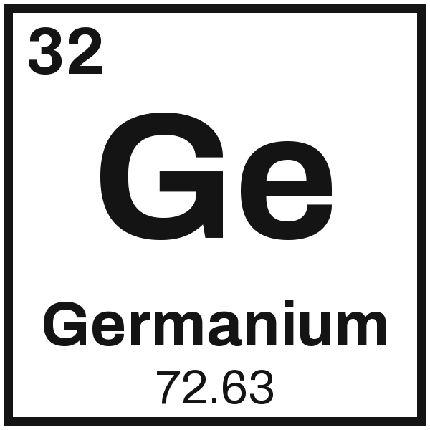 | Configuration Unpaired ____
4 |  | Orbital diagram

5 | 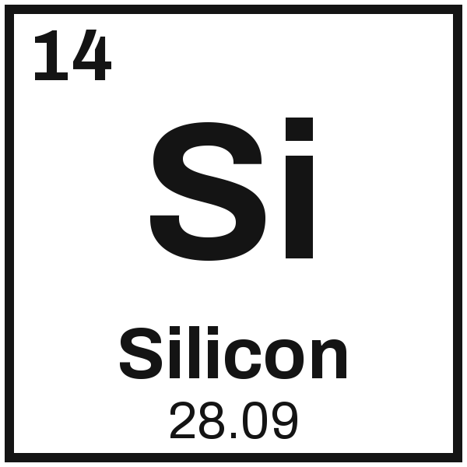 | Configuration Unpaired ____
5 |  | Orbital diagram

3 · NOBLE-GAS SHORTHAND & STABILITY EXCEPTIONS

6  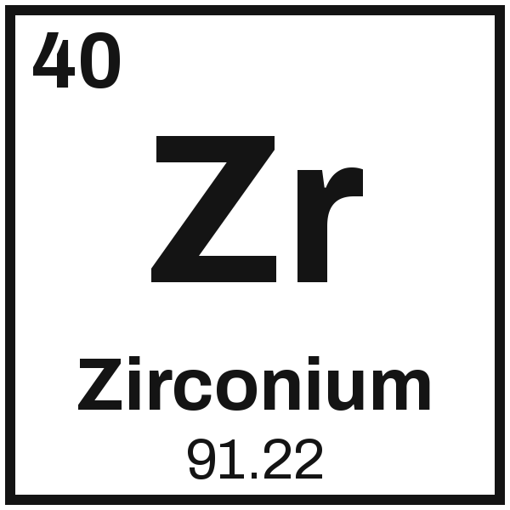 | 7  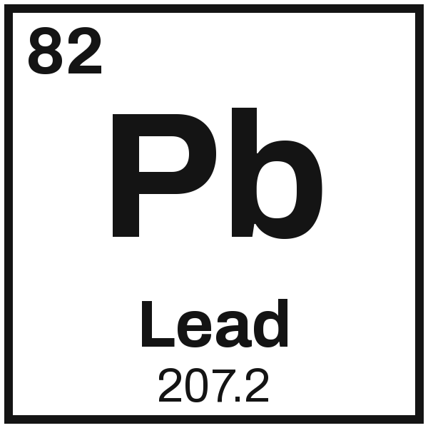 | 8  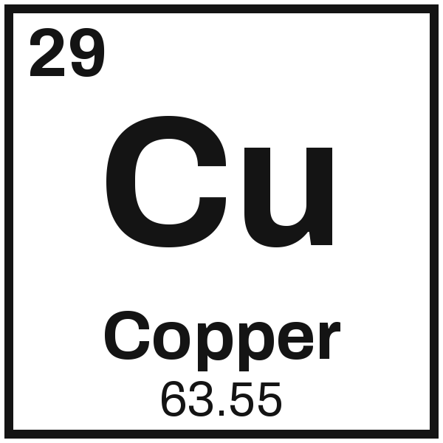

9 Chromium is predicted to be [Ar] 4s² 3d⁴. Write its actual configuration and explain why it changes.

4 · VALENCE ELECTRONS
10 Which sublevels hold an atom's valence electrons? Why don't the d electrons in germanium count?

11 How many valence electrons does each atom have?
ATOM | Cesium, Cs | Boron, B | Bismuth, Bi | Xenon, Xe
Valence e⁻

5 · CATION & ANION FORMATION

ATOM | GAINS OR LOSES e⁻ | ION CHARGE | CATION OR ANION
Lithium, Li
Oxygen, O
Barium, Ba
Fluorine, F
12 An ion has 18 electrons and a 2− charge. Which element is it, and did it gain or lose electrons?

6 · GROUND STATE, EXCITED STATE & FLAME TESTS

STATE | WHAT THE ELECTRON IS DOING
Ground state
Excited state
13 An electron drops from n = 4 to n = 2. Is light absorbed or emitted? Explain.

14 What decides the color of the light an atom gives off?

15 One drop gives off red light and another gives off violet light. Which drop was bigger? How do you know?

16 In a flame test, which ion gives each color?
FLAME COLOR | Yellow | Crimson red | Blue-green | Lilac
Ion
17 Why does each element give its own flame color?

